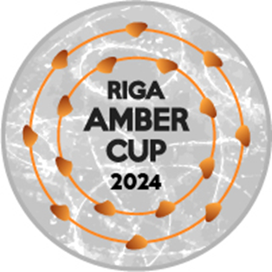

RIGA AMBER CUP 2024

Interclub figure skating competition for single skating and elements

**December 12-15, 2024**

**Riga, Latvia**

Plānoto Elementu saraksts/Planned Program Contents

|  |  |
| --- | --- |
| ISU Federācija/ISU Member Federation |  |
| Kluba nosaukums/Club |  |
| Kategorija/Category |  |
| Sportista vārds, uzvārds/Name of Competitor |  |
| Treneris/Coach |  |

**ELEMENTI IZPILDĪŠANAS SECĪBĀ/ELEMENTS IN ORDER OF SKATING**

|  |  |  |  |  |
| --- | --- | --- | --- | --- |
|  | **Elementi īsā programma / Elements SP** |  |  | **Elementi izvēles programma / Elements FS** |
| **1** |  |  | **1** |  |
| **2** |  |
| **2** |  | **3** |  |
| **4** |  |
| **3** |  | **5** |  |
| **6** |  |
| **4** |  | **7** |  |
| **8** |  |
| **5** |  |  | **9** |  |
|  | **10** |  |
| **6** |  |  | **11** |  |
|  | **12** |  |
| **7** |  |  | **13** |  |
|

Lūdzam nosūtīt Organizatoriem līdz **1.12. 2024**/To be sent to Organizing Committee by email until **December 1st , 2024**: [rigaambercup@inbox.lv](mailto:rigaambercup@inbox.lv)