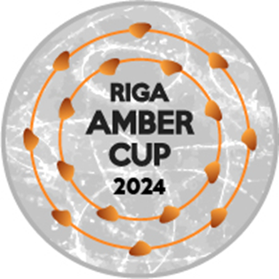

RIGA AMBER CUP 2024

Interclub figure skating competition for single skating and elements

**December 12-15, 2024**

**Riga, Latvia**

Dalībnieku saraksts/Entry list

|  |  |
| --- | --- |
| ISU Federācija/ISU Member Federation |  |
| Kluba nosaukums/Club |  |
| Kontaktpersonas vārds/Contact person |  |
| Tālrunis/Contact phone number |  |
| Epasts/Email |  |

|  |  |  |  |  |
| --- | --- | --- | --- | --- |
| No. | Vārds/Name | Uzvārds/Surname | Dzimšanas datums/Birth date  dd.MM.yyyy | Kategorija/Category |
| 1. |  |  |  |  |
| 2. |  |  |  |  |
| 3. |  |  |  |  |
| 4. |  |  |  |  |
| 5. |  |  |  |  |
| 6. |  |  |  |  |
| 7. |  |  |  |  |
| 8. |  |  |  |  |
| 9. |  |  |  |  |
| 10. |  |  |  |  |
| 11. |  |  |  |  |
| 12. |  |  |  |  |
| 13. |  |  |  |  |
| 14 |  |  |  |  |
| 15. |  |  |  |  |
| 16. |  |  |  |  |
| 17. |  |  |  |  |
| 18. |  |  |  |  |
| 19. |  |  |  |  |
| 20. |  |  |  |  |

Lūdzam nosūtīt Organizatoriem līdz 1.11. 2024/To be sent to Organizing Committee by email: [rigaambercup@inbox.lv](mailto:rigaambercup@inbox.lv) until **November 1st , 2024.**